./

GENESIS - Learning Outcome & Mini-project Summary Report



|  |  |  |  |  |  |
| --- | --- | --- | --- | --- | --- |
| **Ver. Rel. No.** | **Release Date** | **Prepared. By** | **Reviewed By** | **To be Approved** | **Remarks/Revision Details** |
| 1. |  | Nitin N Shetty |  |  |  |
|  |  |  |  |  |  |

**Details**

Contents

Contents 3

Miniproject -1 [Team/Individual] 4

Module/s 4

Topic and Subtopics 4

Objectives & Requirements 4

Design 4

Test Plan 4

Implementation Summary 4

Video Summary 4

Git Link 4

Git Dashboard 4

Summary 4

Individual Contribution & Highlights 5

Summary 5

Challenges faced and how were they overcome 5

Future Scope (If applicable) 5

Miniproject -2 [Team/Individual] 6

Module/s 6

Topic and Subtopics 6

Objectives & Requirements 6

Design 6

Test Plan 6

Implementation Summary 6

Git Link 6

Git Dashboard 6

Summary 6

Individual Contribution & Highlights 6

Summary 6

Challenges faced and how were they overcome 6

# Miniproject -1 [Team]

## Module/s

SDLC (Software Development Life Cycle)

### Topic and Subtopics

## Objectives & Requirements

High Level Requirement

Factorial

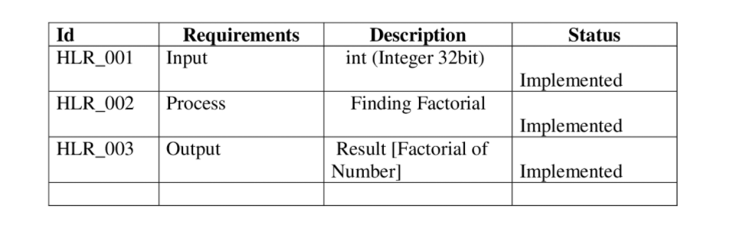

Logarithm

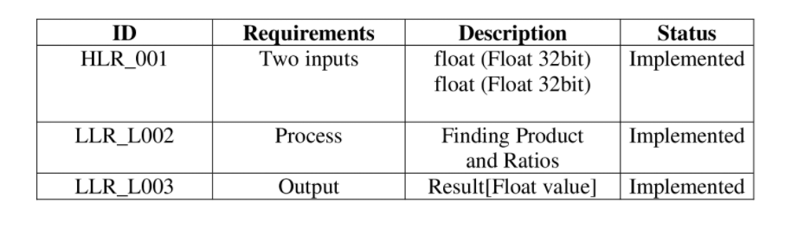

## 

## Low Level Requirement

Factorial

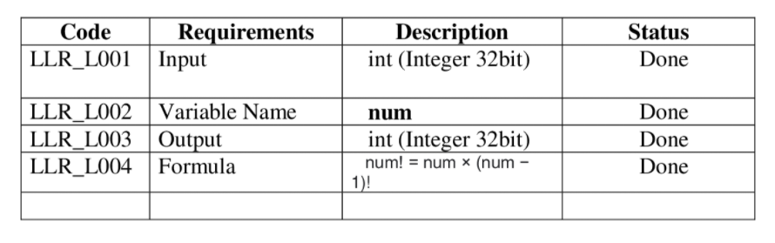

Logarithm

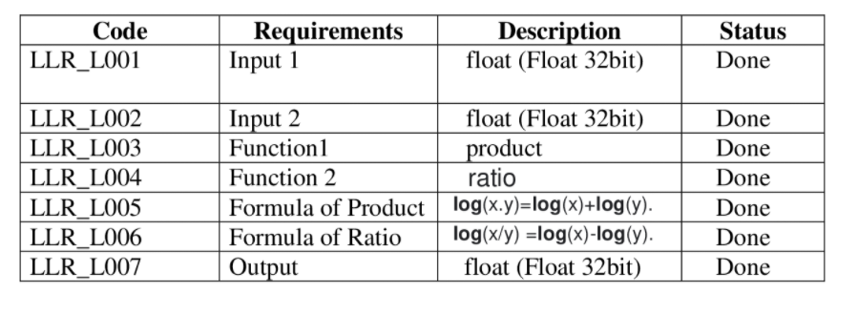

## Design

“System Level and subsystem level UMLs – Structural and Behavioral”

Structural :-

Logarithm:-

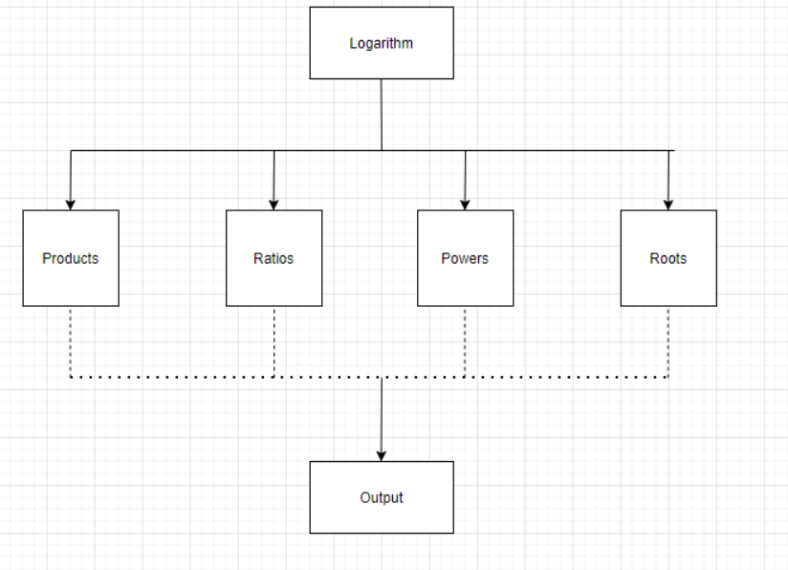

Factorial:-

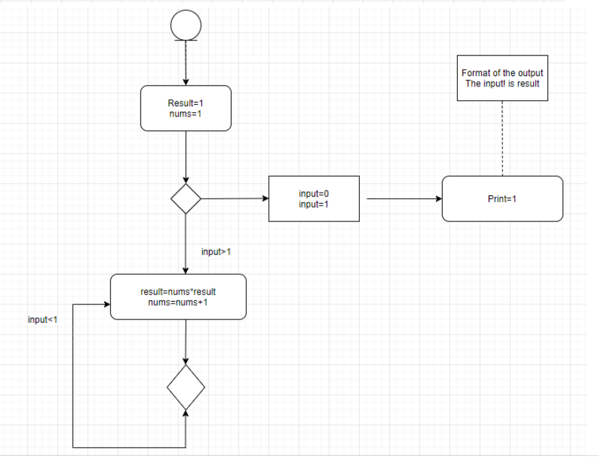

Behavioral:-

Logarithm:-

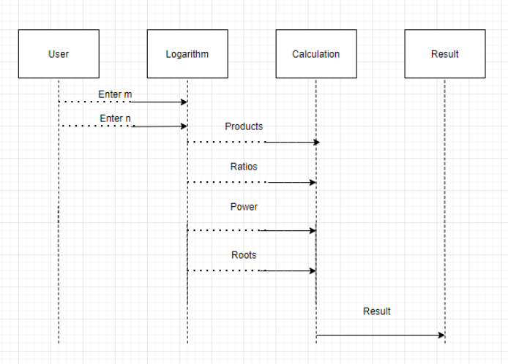

Factorial:-

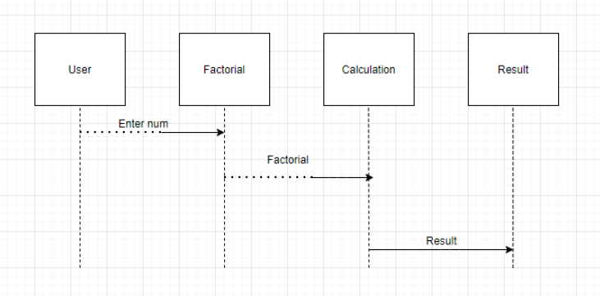

## Test Plan

“Integration level and unit level in the template”

Factorial

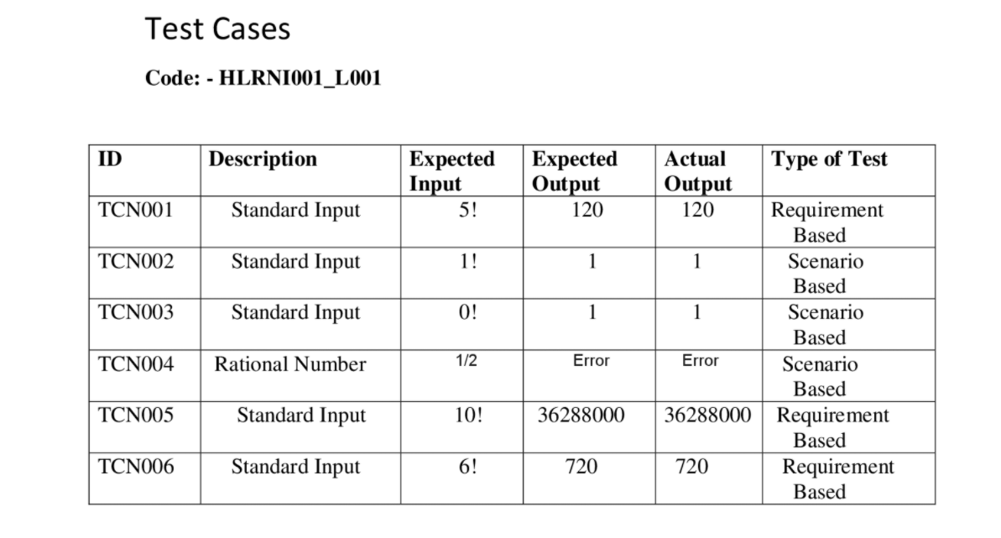

Logarithm

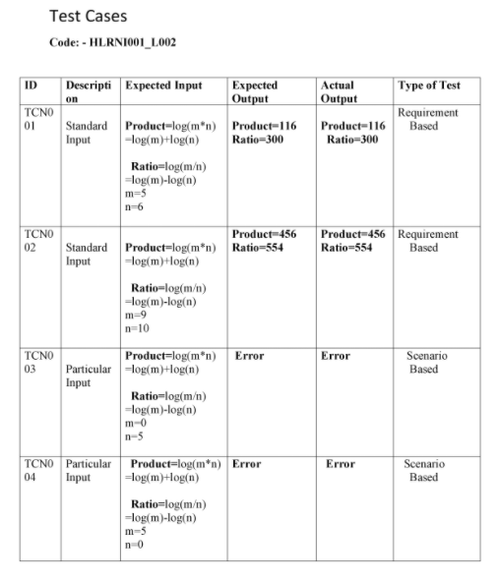

## Implementation Summary

“Section focused toward’ s implementation aspects. Here it is only core summary while all the details are in the Git Repo

Note: The GitHub private repo should be documented (Readme.md files at each folder level)

Ensure code quality and clean code and description practices

Mandatory: To add the GitHub user - **stepin654321** as a contributor to the repo”

### Video Summary

“Please upload a short video on the repo for the walkthrough of the project (Team/Individual) less than 7min and less than 30MB File Size. Start is the Standard opening slide with title of miniproject + Team members followed by the walkthrough ”

### Git Link

### <https://github.com/99003738/AppliedSDLC_N3.git>

### Git Dashboard

Badges:-

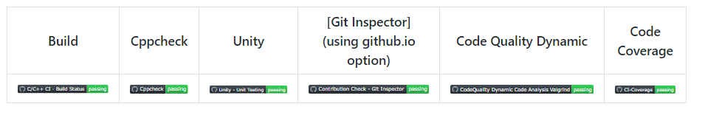

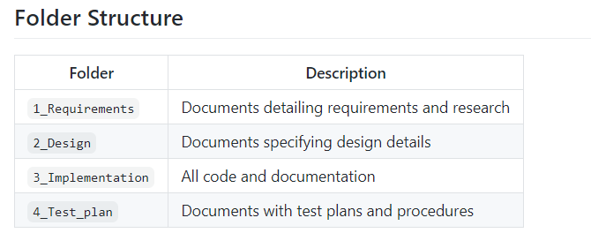

### 

### Summary

“Brief summary on the overall implementation”

#### Git inspector summary

#### 

#### Build

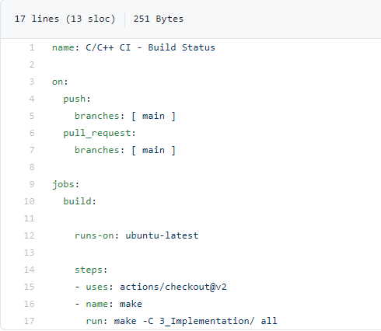

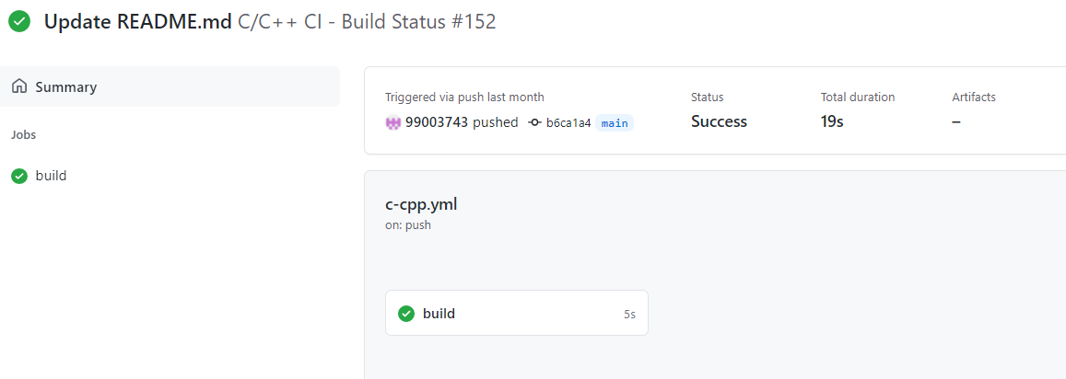

#### Code quality and Issues or Bug Tracking

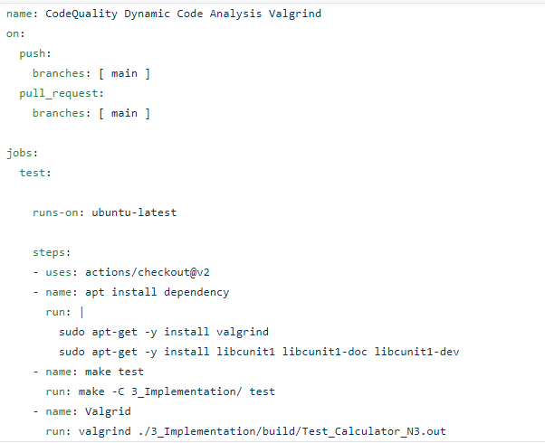

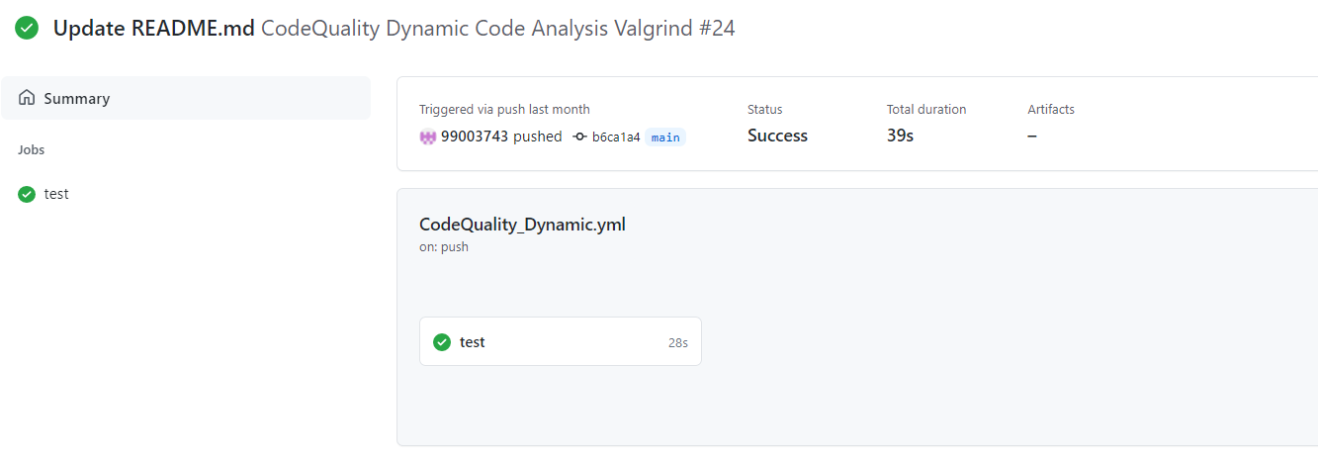

#### Unit Testing

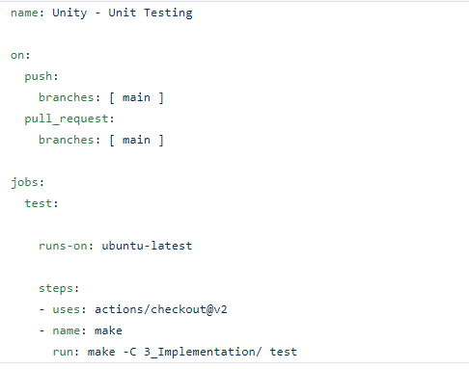

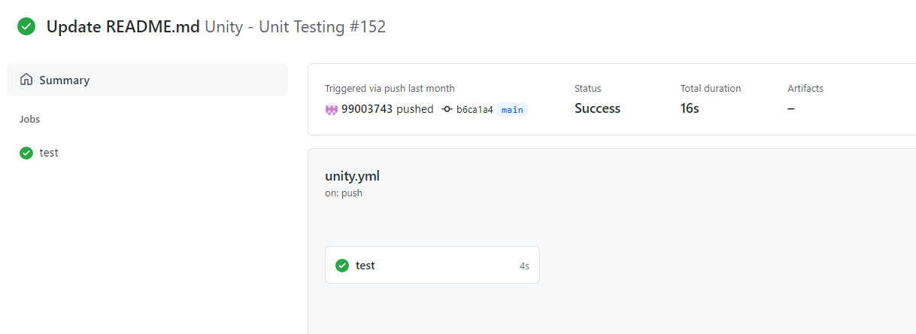

#### Individual Contribution & Highlights

“Brief on Contributions by you for Team”

### Summary

“Key Highlights not covered till now, Softskills and technical side”

### Challenges faced and how were they overcome

“Brief and crisp”

### Future Scope (If applicable)

### 

# Miniproject -2 [Individual]

## Module:- Python

### Topic and Subtopics

## Objectives & Requirements

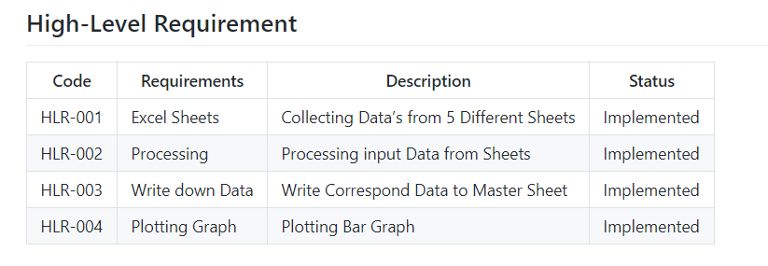

## 

## 

## Design

High Level Design

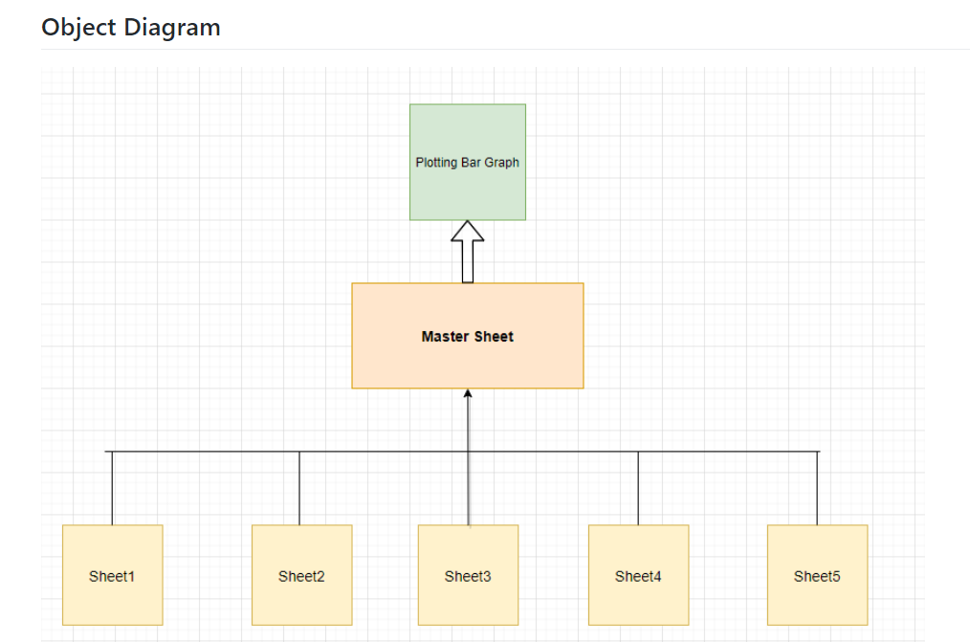

## 

## Low Level Design

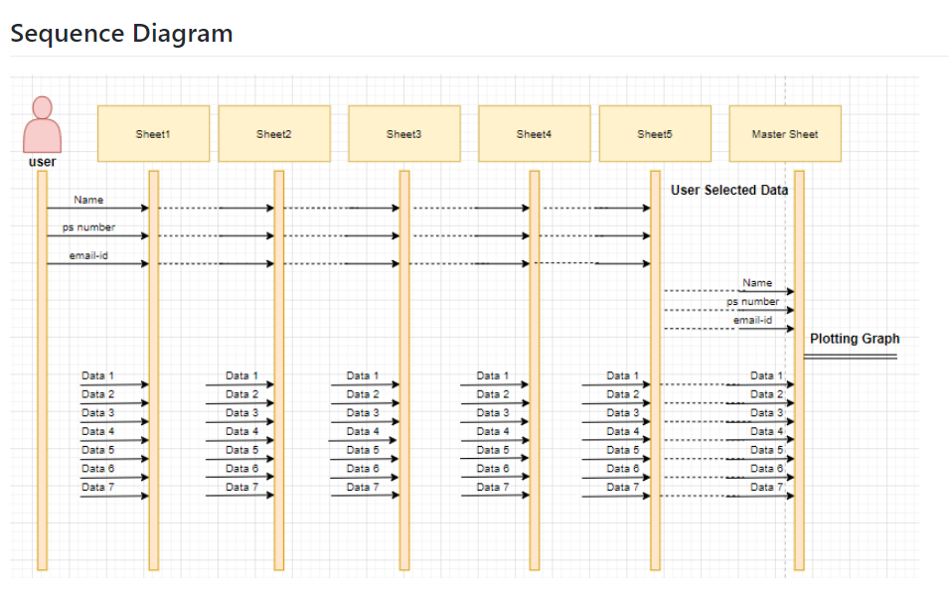

## Test Plan

## Implementation Summary

### Git Link

<https://github.com/99003746/Mini_Project_Python.git>

### Git Dashboard

### Summarys

## Individual Contribution & Highlights

### Summary

### Challenges faced and how were they overcome